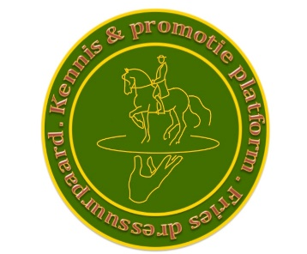

General terms for the European Championships 13 en 14 oktober 2018

- Board/Organisation of Stichting Kennis & Promotie Platform Fries Dressuurpaard, and also the owner of the accomodation, are in no way responsible for any damage or accidents, occured or overcome by competitors, horses, visitors and material. Everyone competes or visits the event at their own risk;
- In the whole complex you are not allowed to smoke;
- The usage of drugs or other substances is strictly forbidden;
- Outside the canteen the usage of liquor is also not allowed;
- Dogs are not allowed in the inside arena and not on the outside grounds;
- You have to follow the indications of the traffic controller;
- On the grounds is the main accommodation;
- You have to keep the outside grounds clean and tidy;
- You are not allowed to use blackening or hoofoil on the grounds
- During the competition the practice ring is exclusive for the competing combinations and officials;
- If the ringmaster calls in a combination it instantly needs to go the ring entrance;
- Competitors need to comply to directions given by the ringmaster or officials;
- In case these terms don’t provide, the board of the “Stichting K & PP” in consultation with the federation representative of the KNHS will decide.

